# **How to Edit the Front/Home Page Content**

1. **Log in to the WordPress Dashboard**

* 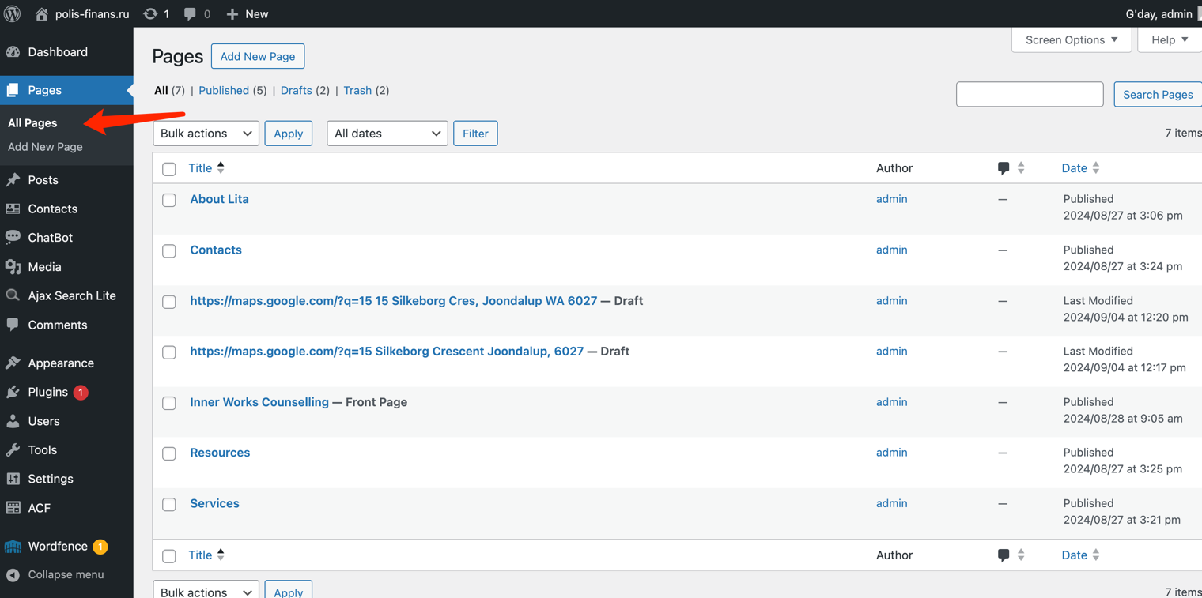On the left sidebar menu, click on "Pages – All Pages".

1. **Select the ‘Front page’ to Edit**

* A screenshot of a computer

  Description automatically generatedOn the Pages screen, locate the "Front page" page in the list of pages. Hover your mouse over the "Front" page title and click "Edit" when it appears.

1. **Edit the content**

* By using page editor, title and content can be changed simply clicking on the paragraph you want to modify.

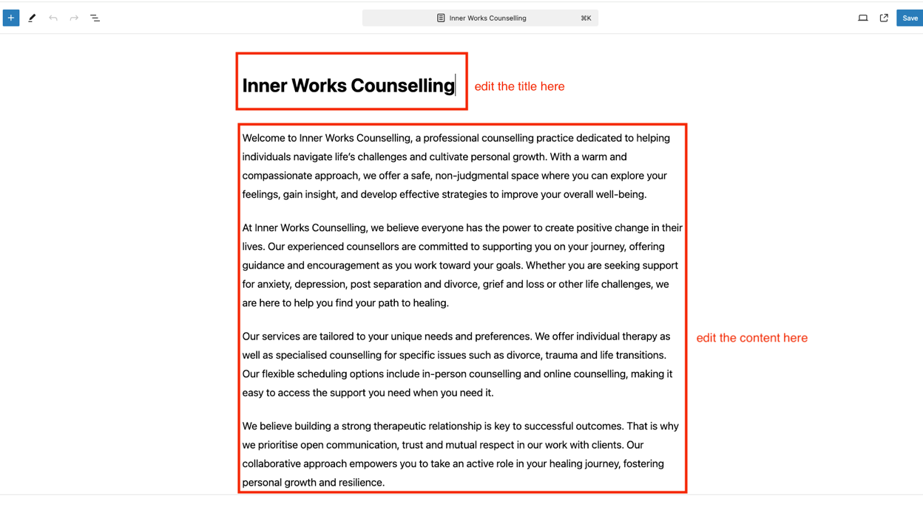

* Use toolbar to format your text when editing content.

**4. Edit text in the header**

* To edit the text in the header as per the screenshot below, scroll down to the bottom of the page.

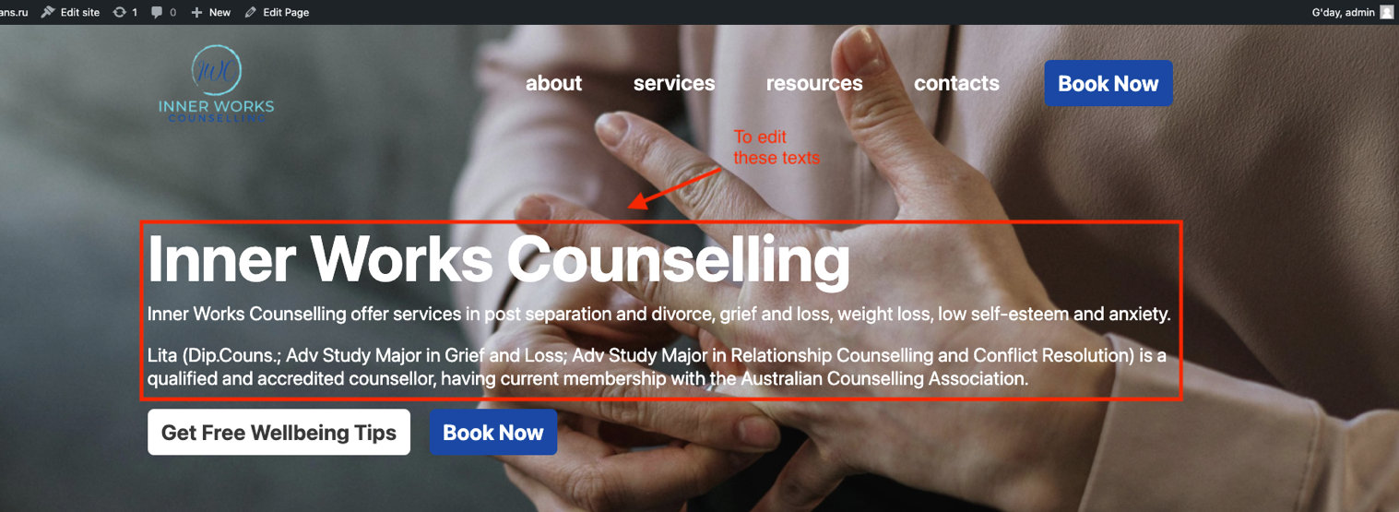

* A screenshot of a computer

  Description automatically generatedText in these 3 containers will appear in the header.

**5. Adding new content**

* Click on the “+” icon on the top left of the editor to add new blocks e.g. paragraphs, headings, images, etc.

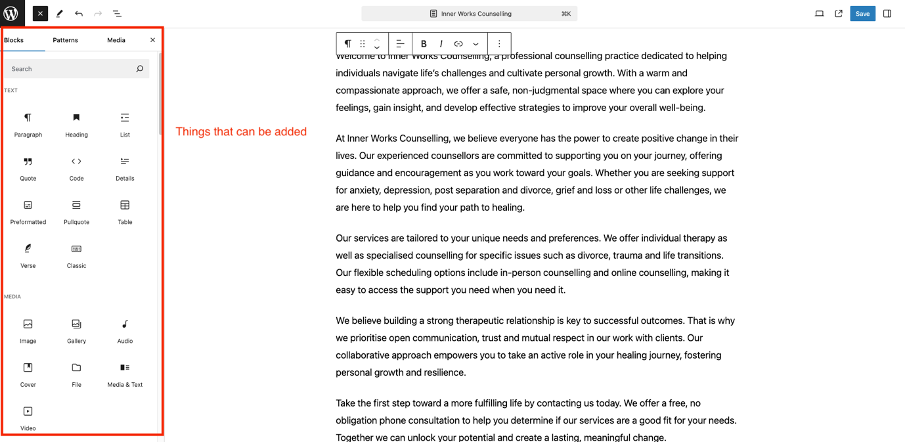

**6. Preview and Save Changes**

To preview your changes, click the laptop icon in the top right corner. This opens a dropdown menu with several options:

* Desktop: Preview how the page looks on desktop screens.
* Tablet: Preview the page layout for tablet devices.
* Mobile: See how the page appears on mobile phones.
* Preview in new tab: Opens a full preview of the page in a new browser tab.

After previewing, click the "Save" button to publish your updates. Visit your website to verify the changes appear as intended.